**PROJECT PROPOSAL**

1. **Mini-Challenge 1: Crowdsourcing for Situational Awareness**

*- Sravani Gandla, Venkat Kowkuntla, Rajashekar Pinreddy,*

*Rithika Mamidi, Sanjana Dasari, Kavya Rajula*

**DOMAIN ABSTRACTION**



Mini challenge 1 of VAST Challenge 2019 focus is to categorize the neighborhood cities to send an immediate response based on two metrics damage and uncertainty.

St. Himark is a fictitious place that has been hit by an earthquake. People in different locations of this place are sending data of various levels of damage through an app from time to time. The main tasks which we are going to focus on are how to prioritize the cities to send resources to the cities based on the intensity of damage analyzed from the data provided by the people. The other important task is to find uncertainty in the data and visualize it on a timely basis. Our main aim is to create an interactive visualization system that focuses on prioritizing the neighborhood based on damage intensity and the uncertainty in reported data with the location.

**TASK/DATA ABSTRACTION**



The first step of the visualization system is Data Abstraction.

We have six dimensions of categorical data for every 5 minutes of 19 locations. We are using the mean to calculate the damage to prioritize the locations based on damage intensity. Uncertainty in the data is calculated using entropy for each dimension.

**IDIOM ABSTRACTION (VISUALIZATIONS AND INTERACTIONS)**



The Second step is Visualizations:

Based on the data that we have from a high level to the low level; we have decided to have five visualizations with different functionalities/tasks.

1. Map visualization to show high level damaged regions and uncertainty for the selected dimension.

2. Combination of Grid and Heat Map to show the combined visualization of damage intensity for all dimensions of data.

3. Stacked Bar chart to display the topmost affected regions.

4. Line Chart to show average damage intensities of cities over time.

5. Density Plot is used to display the timed event series

**ALGORITHM ABSTRACTION**



We are performing data analysis with python. For the visualization we are going to use React JS framework with D3.js as main focused JS library. The full stack will be Python, Flask and React. According to the function we will choose to process the data either in the backend/frontend.

**VISUALIZATIONS AND INTERACTIONS**



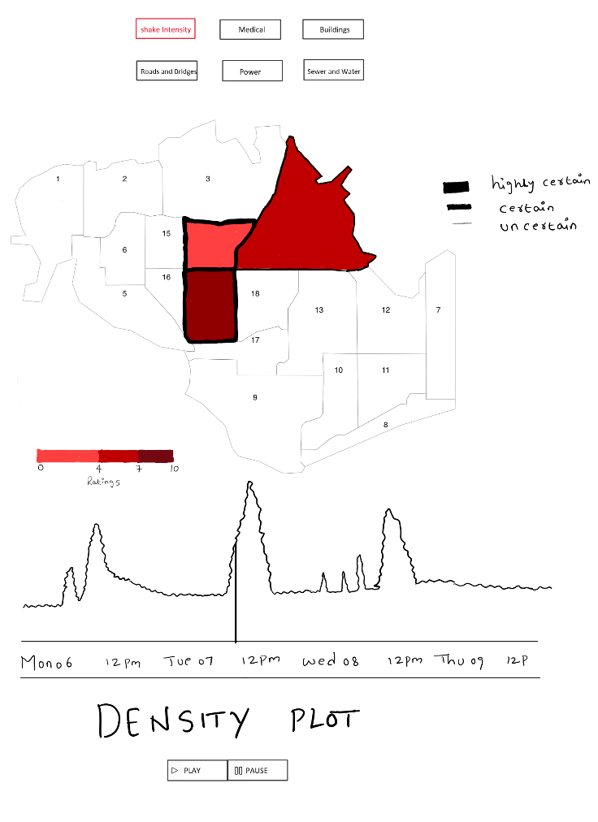

The density plot is the plot between time marked for every 5 mins on x axis and average of ratings for every 5 mins on y-axis. The plot helps us to navigate to point where we received highest average ratings (most impact point) and see which area and what service is impacted the most. It is a visualization to show the damage for one dimension at a time.

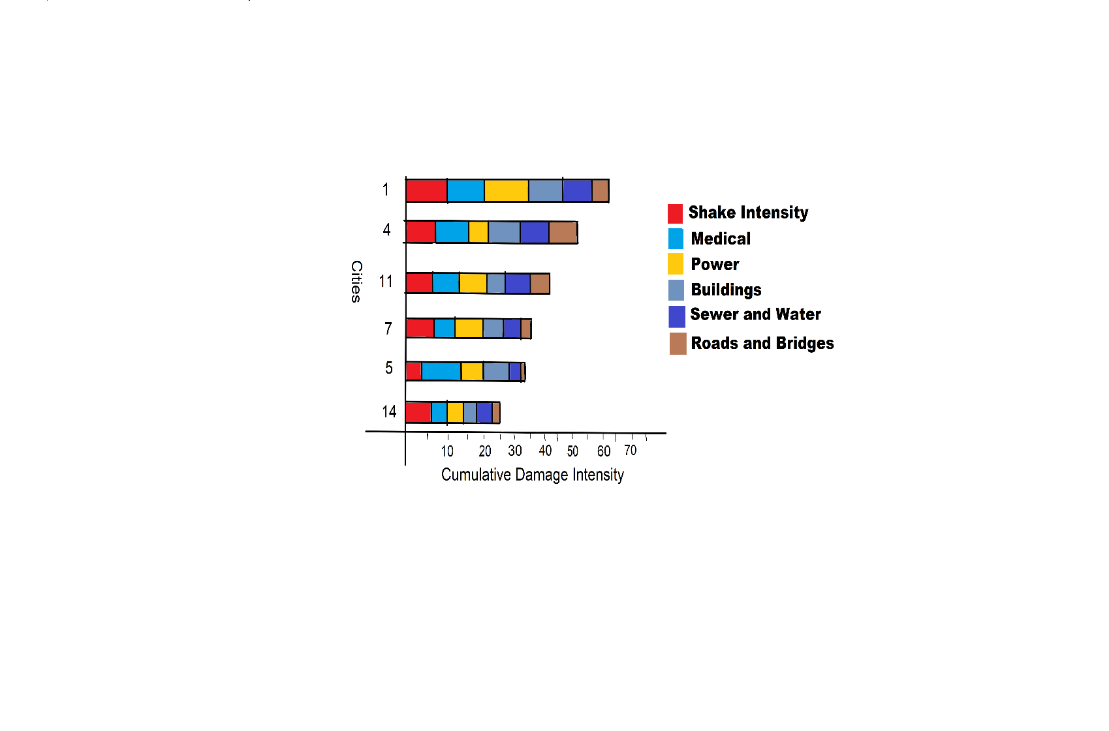

The above visualization is to demonstrate the top 6 impacted areas at a given time point based on the cumulative damage intensity.

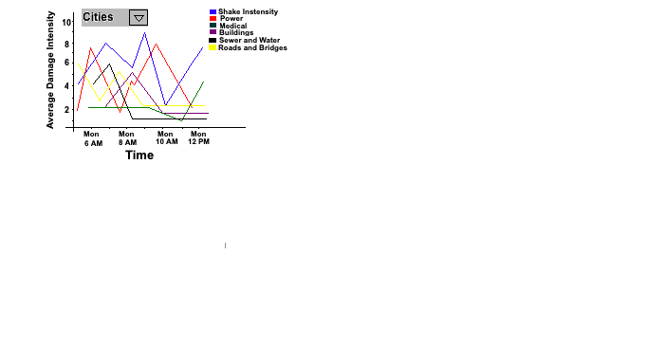

The above visualization shows the average damage intensity for the selected city aggregated for every one-hour interval.

**INNOVATIVE VIEW**

****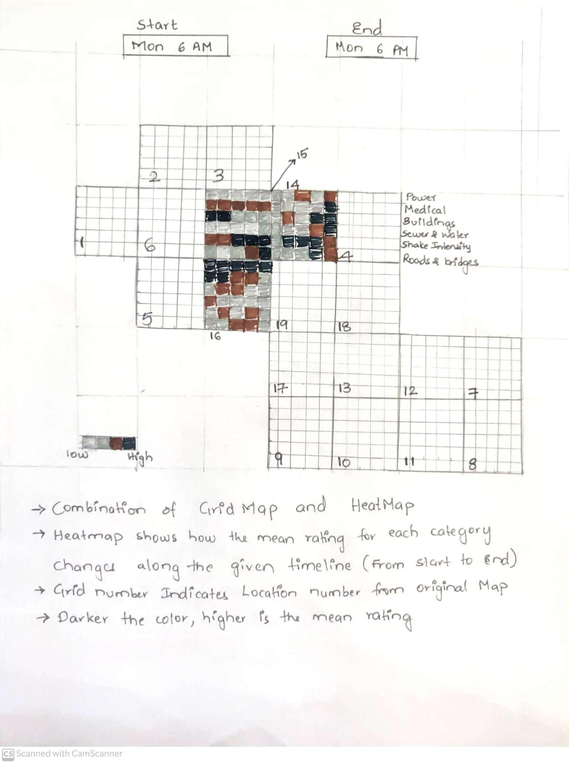



It is a combined visualization to show damage intensities for all dimensions.

**EXPECTED TIMELINE**



**Week 1-2 (Sep28 - Oct11):** Data Preprocessing, Frontend React Setup and Backend Flask Setup. Basic GeoMap and Grid Map Visualization

**Week 3-4 (Oct12 - Oct25):** Developing all 5 visualizations on the frontend. Making APIs for the required data

**Week 5-6 (Oct26 - Nov8):** Enhancing visualizations, adding legends/titles/tooltips and UI interactions

**Week 7-8 (Nov9 - Nov22):** Review, Testing and Team Report

**Buffer Week (Nov23 - Nov29):** Review

**Week 9:** Presentations.

**TASK DIVISION**



* Data Preprocessing: Kavya, Sanjana
* Backend and Frontend Architecture: Rithika, Sravani
* Frontend and Visualizations:
* Geo-Map: Team
* Grid Map with Heat Map: Team
* Stacked Bar: Kavya
* Density chart with timeline: Venkat, Rajashekar
* Line chart: Sanjana
* Review and Testing: Team
* Report: Team
* Presentation: Team